* Unzip Lab2-Kagdi.zip

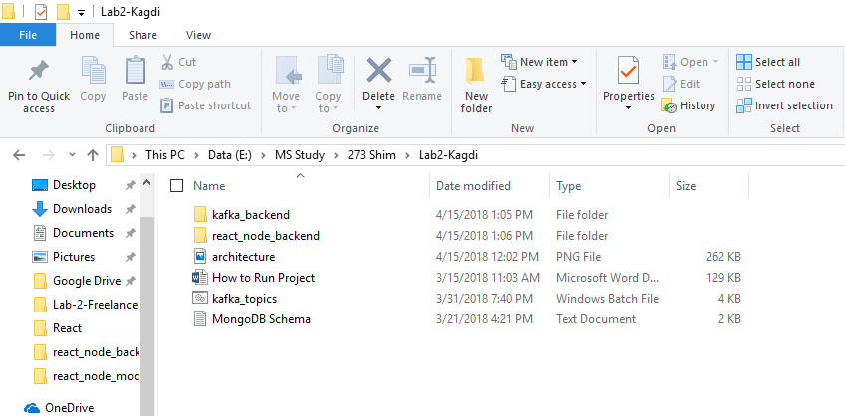

* Kafka Installation:
  + [Download](https://www.apache.org/dyn/closer.cgi?path=/kafka/1.1.0/kafka_2.11-1.1.0.tgz) the kafka latest release and un-zip it.
  + Go to kafka directory: cd kafka_2.11-1.1.0
  + **Start Zookeeper**: bin/zookeeper-server-start.sh config/ zookeeper.properties
  + **Start Kafka :** bin/kafka-server-start.sh config/server.properties
  + **Create Topics :** Lab2-Kagdi/kafka_topics
* React-Client and Node-Backend
  + Open Terminal window
  + Go to Path : cd Lab2-Kagdi \react_node_backend

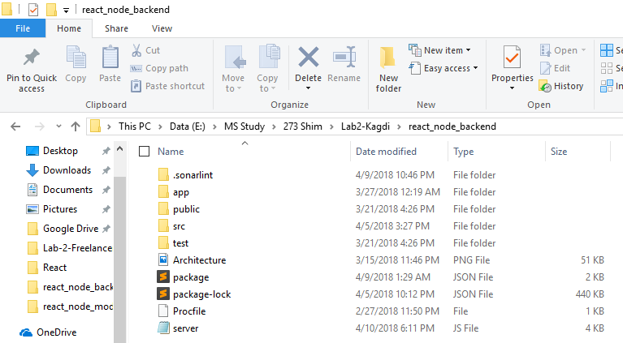

* Install all dependencies as mentioned in package.json
  + npm install
* Run Command to start server:
  + npm run start-dev
* **Note**: This will start ReactJS server on 3000 port and node_backend NodeJS server will start at 3001 port. ‘Foreman’ module is used to start both server together. Script is written in ‘Procfile’.
* Kafka_backend

* + Open Terminal window
  + Go to Path : cd Lab2-Kagdi \ kafka_backend



* Install all dependencies as mentioned in package.json
  + npm install
* Run Command to start server:
  + node server.js

* **Note**: This will start kafka_backend server.